**Charmhigh Automatic Chip Mounter（CHM-T36VA）**

**Operating Manual**

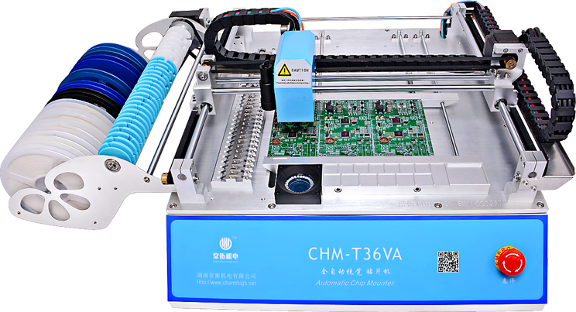

2016

CHARMHIGH TECHNOLOGY LIMITED

**Charmhigh-V1.0-2016**

2016-06-01

**Table of Contents**

1. Revision History 4

2. Install the Machine 4

3. Product List 4

4. Hardware Requirements and Compatible Software 5

4.1. Hardware Requirements 5

4.2. Compatible Software 5

5. Notices 5

6. Technical Parameters 6

7. Glossary and Software Parameters 6

8. Mechanical Structure 8

9. Booting the Machine 9

10. Run 10

10.1. Edit Work File 10

10.1.1. Component 11

10.1.2. Feeder 15

10.1.3. IC Tray 19

10.1.4. Batch 20

10.1.5. PCB 22

10.2. Load Work File 23

11. Diagnostics 24

12. Set 25

12.1. System Set 26

12.2. Vacuum Detection Set 29

12.3. Backup/Restore 30

13. Files 30

13.1. Generating the CSV File 31

13.1.1. Altium Designer 31

13.1.2. Protel 33

13.2. File Convert 36

13.2.1. Feeders 38

13.2.2. Components 38

13.2.3. Batch 39

14. Log 40

15. System Log 41

16. Feeder Hardware 42

17. Nozzle Hardware 44

18. PCB Clamps 44

19. Work Flow 45

20. Maintenance 46

21. Warranty 46

# Revision History

|  |  |  |  |
| --- | --- | --- | --- |
| **No.** | **Date** | **Description** | **Version** |
|  | 2016-06-01 | Create document | V1.0 |

**CHM-T36VA_UserManual_OpenSource1p0**

This revision document is a user-contributed translation of the user manual by a native English speaker that is hopefully clearer than the original CharmHighV1.0. Names have been changed to be more intuitively obvious, consistent across the functions and compatible with industry jargon. Menus are based on software version 3615. New menu descriptions have been created in the file smt_English_OpenSource1p0.qm, which can be renamed to smt_English.qm and copied into the SmtMain folder for use by the SmtMain control program.

# Install the Machine

* Open the packing cases, take out the SMT machine and place it on a strong table;
* Check if the machine is in good condition and the product list. If you have any questions, please contact us;
* Please read this manual carefully before use the SMT machine;
* If there are any problems in use, you are welcome to contact us.

# Product List

|  |  |  |  |
| --- | --- | --- | --- |
| **No.** | **Parts** | **Quantity** | **Remarks** |
|  | SMT machine | 1 | - |
|  | nozzles | 4 | 503,504,505,506 |
|  | USB flash disk | 1 | 8G |
|  | power cord | 1 | - |

# Hardware Requirements and Compatible Software

## Hardware Requirements

All equipment is built-in. An external control computer is needed for the CHM-T36VA model.

It is recommended the machine be placed on a sturdy table or floor. Strong room lights may degrade the visual alignment system.

## Compatible Software

CSV input files are compatible with Protel99se and Altium Designer.

# Notices

1. Keep the machine away from humidity and dust, otherwise may cause electric shock or fire;
2. Do not place the machine in the platform of instability or tilted, otherwise the vibration of the machine when working may lead to lower precision, even personal injury caused by overturned;
3. Don't disassembling machine, or may be led to the decrease of the accuracy or machine damage;
4. Don't use hand to touch the moving parts, otherwise it may damage the machine or cause personal injury;
5. New machine components containing volatile substances, it need to maintain good ventilation in the first few days using;
6. The power cord can only be used for the machine, otherwise may damage the other electrical appliances;
7. Ensure the power supply meet machine nominal requirements;
8. Ensure the power supply socket with good grounding;
9. Keep the machine away from flammable and explosive goods;
10. Place the nozzles and other small accessories in out of the reach of infants and young children;
11. Don't let the pull needle in the stretched state for a long time, or it could be damaged;
12. Don't put machine direct exposure to sunlight or bright light, otherwise may cause the machine precision reduce or damage to the machine.

# Technical Parameters

**主要技术参数**

|  |  |
| --- | --- |
| model | CHMT36VA |
| PCB area | 10mm×10mm～355mm×355mm |
| X, Y axis stroke | 400×460mm |
| Z axis stroke | 15mm |
| number of nozzles | 2 |
| feeders | ordinary feeders 29 pcs, front bulk IC tray 14 pcs |
| visual support | dual cameras |
| Motor drive | Closed-loop servo high-voltage drive system  (Ensures the accuracy of operation) |
| Z axis back position detection | Yes |
| Pull needle auto return | Yes |
| Leak detection method | Vacuum detection, Vision detection |
| System | Windows 7 |
| need external air pump | No (built-in mute air pump) |
| need external PC | Yes |
| power supply | 220V(110V), 50Hz |
| power | 250W |
| weight | 65Kg |
| volume of packaging | 0.41m­­3 |

# Glossary and Software Parameters

*Component electrical part placed on PCB*

Component ID software identification number

Component height used to program displacement of nozzle

Component size used for visual centering system

Component skip used for no component placement

Component designator PCB silkscreen identification

Component comment information used to sort into feeders

Component place offset offset for all components during place operation

*Feeder mechanism to hold parts and advance tape, or tray position*

Feeder physical location number

Feeder ID software identification number

Feeder advance length of tape pull for advancing to next part

Feeder speed speed of tape pull

Feeder needle located on head, used to pull feeder tape

IC tray integrated circuit tray; fixed at front or user-defined at back

*Nozzle part that holds component with vacuum suction*

Nozzle nozzle section 1 or 2 when picking part

*Pick picking up component at feeder*

Pick angle part orientation in tape, normally in 90 degree increments

Pick offset x and y offset of nozzle at pick up

Pick mode selects normal or dual (nozzle) placement mode

Vision centering enable vision system to center component

Vacuum checks vacuum indicates part picked up

*Place placing down component on PCB*

Place speed head movement speed

Place angle angle of component part on PCB

Place coordinate location of component part on PCB

*Calibrate calibrating the machine’s positioning systems*

Calibrate cameras centers x-y stage coordinate system to cameras

Calibrate component fine tunes alignment of components

Calibrate feeder fine tunes position of feeders

Calibrate PCB finds position of 2 or 3 points on PCB

Calibrate cameras centers Up Camera to Down Camera

Calibrate nozzle centers nozzle in vision system

Up Camera used to measure offset of component center with vision

Down Camera used to align feeder and PCB

Up Light corresponding light

Down Light corresponding light

*Head part with nozzles, down camera and needle for tape pull*

Origin reset send head to front-left to reset origin via limit switches

Home send head to back-right position (for loading)

Batch making a panelized array for multiple PCBs

PCB ID batch number identification for multiple PCBs

Step step number when placing components

\toggle indicator for toggling function, turn on/off

# Mechanical Structure

The figure below shows the machine layout as a whole.

**解说图（加注）En**

**Figure 8.1.** Description of machine systems.

1. **Nozzle**: Machine supports two nozzles, used for picking up components. Nozzle 1 is on the left and nozzle 2 on the right;
2. **Pull needle for feeder advance**: Used to advance tape through the feeders. Don’t let the needle be in a stretched state for a long time or it could be damaged;
3. **Down Camera**: Used for observing the feeders, PCB or components;
4. **Up camera**: Vision centering used for calibrating the components position and angle to improve placement accuracy;
5. **IC tray (PCB) clamping area**: Used for mounting a user-supplied IC tray;
6. **PCB clamping area**: Used for fixing PCB. Use the PCB stop on the left, with spring clamp on the top;
7. **Feeders**: Feeds tapes of component parts for nozzle for pick up.
8. **Belt receiving wheel**: Used for collecting cover film after separated from tape;
9. **Tape placing area**: Used for placing tape and reels;
10. **IC Tray**: Fixed tray used for placing larger ICs;
11. **USB interface**: Used for connecting the USB storage device;
12. **Emergency stop switch**: Emergency stop when pressed down. Normal operation when rotated clockwise and pushed out;
13. **Power switch**: Turn on this switch to boot software. When shutting down, first close the software and then turn off this switch.

# Booting the Machine

Turn on the power switch and then run the “SmtMain” program. If camera device not connected, close software, power down, unplug/plug USB cable and then turn on again.

Wait for the machine to load the operating system, self-check and perform an origin reset. When the machine start is complete, the display screen is shown below.

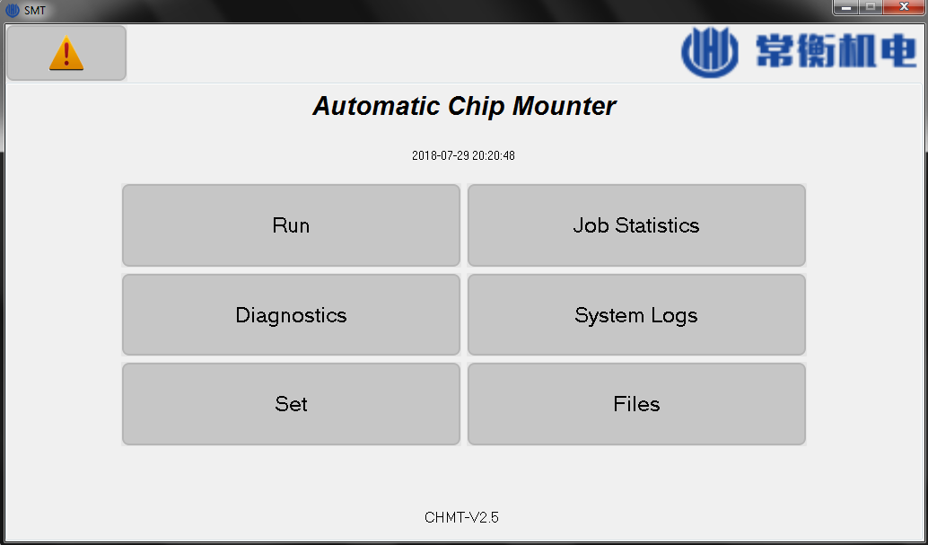

**Figure 9.1.** Top-level window, showing high-level functions.

1. **Alarm:** Located upper left. View current alarm and cause;
2. **Run:** Load working files and running the machine;
3. **Diagnostics:** Diagnostic tests of module functions;
4. **Set:** Set various parameters of the machine;
5. **Job Statistics:** View the job record information;
6. **System Logs:** View the system log;
7. **Files:** Manage and convert work files.

# Run

The machine needs to select a work file to run. From the main screen, click on the “Run” button to display the following screen, where the work file can be selected.

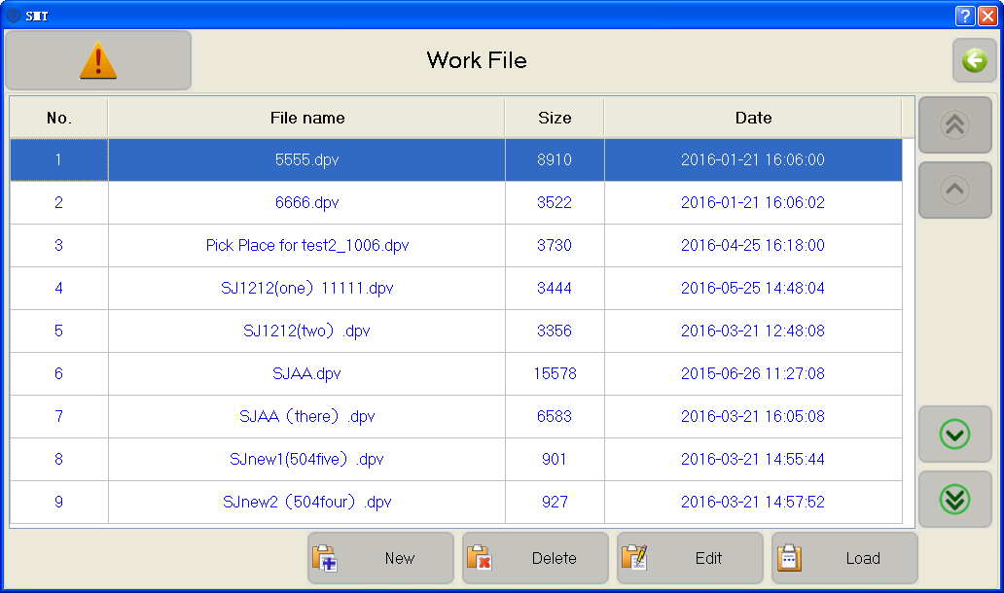

**Figure 10.1**. Window after “Run”, showing work files.

1. **Work file list:** The middle of the screen lists existing work files “*.dpv”. Click to select the work file. The single or double arrows on the right are used to select a previous line or page;
2. **New:** Create a new work file;
3. **Delete:** Delete the selected work file;
4. **Edit:** Edit the selected work file;
5. **Load:** Load the selected work file to run;
6. **Back:** Click left arrow button on the upper right corner of the screen to return to the previous level window. All windows behave similarly;

## Edit Work File

The work-file edit window can edit component, feeder, batch, IC tray and PCB calibration, as chosen by the tabs.

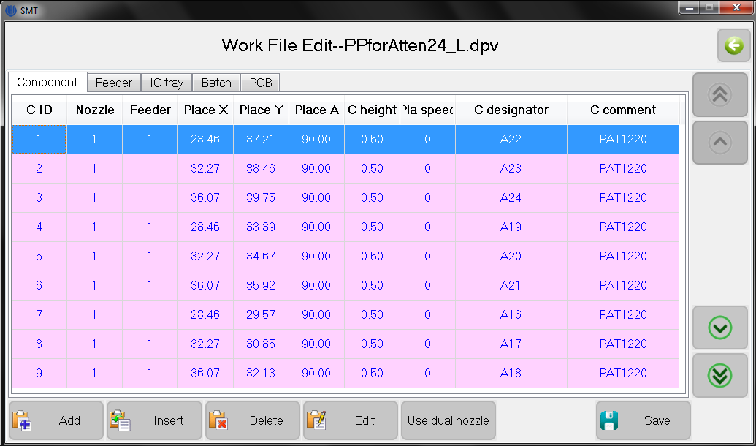

**Figure 10.2.** Window after “Run / Edit / Component tab”, listing components.

### Component

The screen shown above is used for managing individual components in PCB. It shows a list of all components in the selected work file. The rows are color coded:

Gray skip component;

White vacuum checks disabled and vision centering disabled;

Orange vacuum checks enabled and vision centering disabled;

Green vacuum checks disabled and vision centering enabled;

Purple vacuum checks enabled and vision centering enabled;

1. **Add:** Add a component to the end of the list;
2. **Insert:** Insert a new component before the currently selected row;
3. **Delete:** Delete the selected component;
4. **Edit:** Edits the selected component, see below for details;
5. **Save:** If you edit a component in the list, the save button will flash. This indicates information has not yet been saved; click to save and stop flashing;

#### Edit

The component edit screen is shown below.

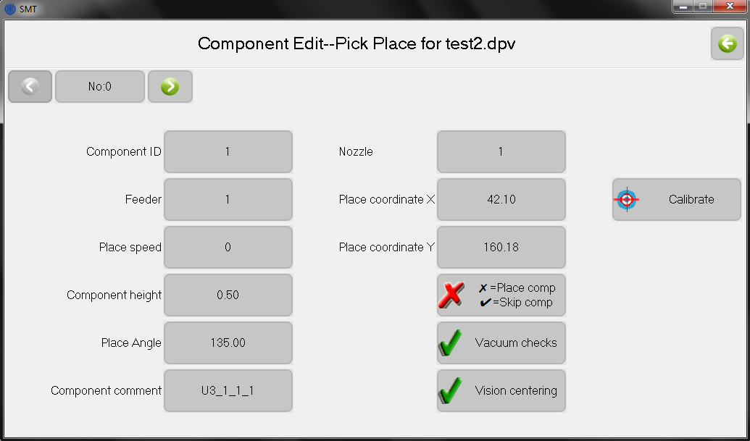

**Figure 10.3**. Window for editing components.

* 1. **Component ID:** Set the Component ID number. This number is unique and cannot repeat in the same work file;
  2. **Feeder:** Set the feeder number (location) of this component. When specifying a new feeder, the feeders list will automatically add a new entry;
  3. **Place speed:** Sets the placement speed, in range 50%-100%. Speed of 0 is equivalent to 100%. 50% reduces speed, which can improve accuracy;
  4. **Component height:** Set component height. Default is 0.5 mm, corresponding to typical resistor thickness. Adjust also for board thickness. Larger values move the nozzle upwards. The nozzle displacement depends on height for the pick operation at the IC tray and place on the PCB, but not during the feeder pick and vision. Height must be less than 5 mm.
  5. **Place angle:** Set placement rotation angle of component on PCB. Counterclockwise is positive, clockwise is negative;
  6. **Component designator:** Designator on silkscreen, such as R1, C2, U1 etc. Here, the text “Component comment” is in error and needs to get fixed;
  7. **Nozzle:** Selects pick-up nozzle 1 or 2;
  8. **Place coordinate X\Y:** Placement component location on PCB in X\Y, typically imported from EDA software;
  9. **✗=Place component, ✔ = Skip component:** Normally use ✗to place parts;
  10. **Vacuum checks:** When checked, measures if vacuum is sufficient to indicate the pick-up of a component. If not, attempts to pick a 2nd time. If still fails, tape is advanced and pick attempted 2 times. After tape is advanced 2 times (3 positions with 6 tries total) with insufficient vacuum, the machine will alarm and stop. It is suggested to uncheck this function when mounting expensive or difficult parts, such as cylindrical components;
  11. **Vision centering:** When checked, the center position of a component will be measured with the vision system to improve placement precision;
  12. **Calibrate:** Opens an additional window to align the component;

#### Component Calibrate

The component coordinate for placement is normally assigned by software when importing the CSV file. A more accurate alignment can be made by checking align component, which sets the position on the PCB using the down camera or nozzle. Its window is shown below.

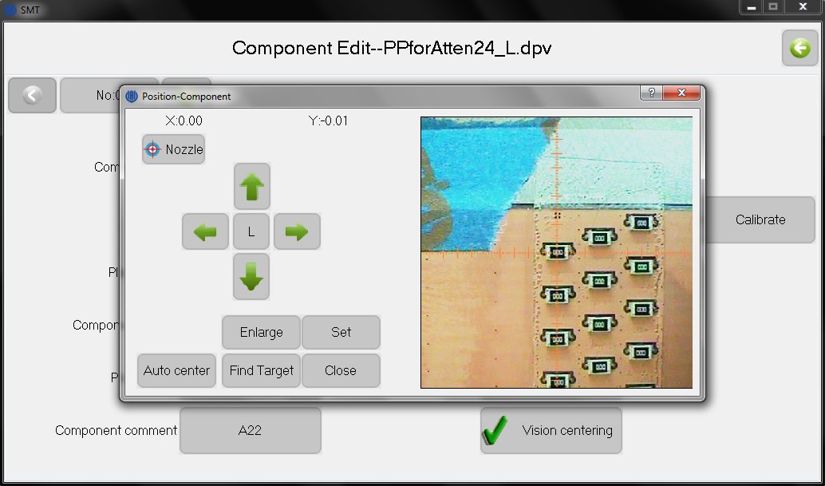

**Figure 10.4.** Visual alignment for components. Here shown after component placement to check for placement accuracy.

* 1. **X\Y:** The component coordinate offsets are displayed in the upper left;
  2. **Move:** The four arrows move the head. The central button toggles the speed, which displays either the high or low (H/L) setting;
  3. **Set:** Saves the current X\Y location as the component coordinate;
  4. **Close:** Closes the window;
  5. **Nozzle\Vision:** Clicking this button toggles between nozzle and vision mode. Additional commands for the two modes are:
  6. **Vision mode:** The center of the down-camera image is moved to the component coordinate. The image is displayed on the right. Move the image until the crosshairs are centered on the component.
     1. **Enlarge:** Toggles between a normal and zoomed-in image;
     2. **Find Target:** Locates the component center automatically. The algorithm searches from the image center outward, and the first closed graph is identified as the target and marked with a red rectangle. This target, typically a silk-screen pattern, must image cleanly and be closed. Positioning with the silk screen is not always accurate, so the alignment should also be checked manually with the footprint.
     3. **Auto Center:** Move to the center of target if target was captured;
  7. **Nozzle mode:** The selected nozzle is placed at the component coordinate. No image is shown.
     1. **Nozzle 1\2 down:** When pressing this button, the nozzle moves down to the PCB. This is used for manual alignment of the nozzle to the pad;

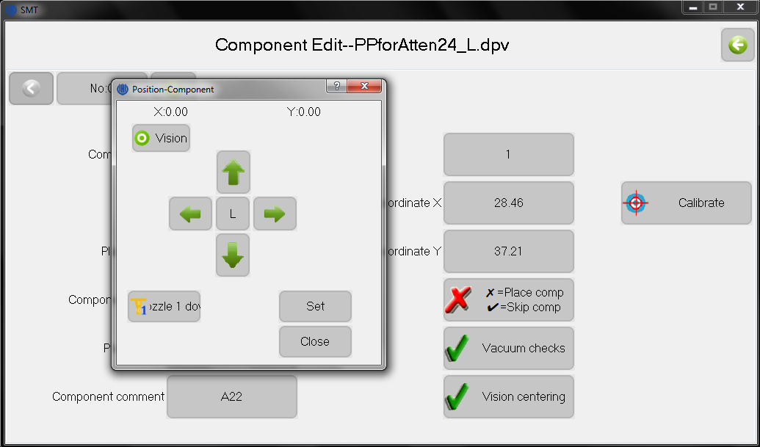

**Figure 10.5.** Visual alignment for nozzle.

### Feeder

User information for setting up a job is typically entered in the feeder tab, which defines what feeders the parts come from. The screen shown below is used to manage the feeder information. Changing feeder parameters make global changes to all components associated to that feeder.

Here, when function descriptions are the same as in components tab, it is left blank.

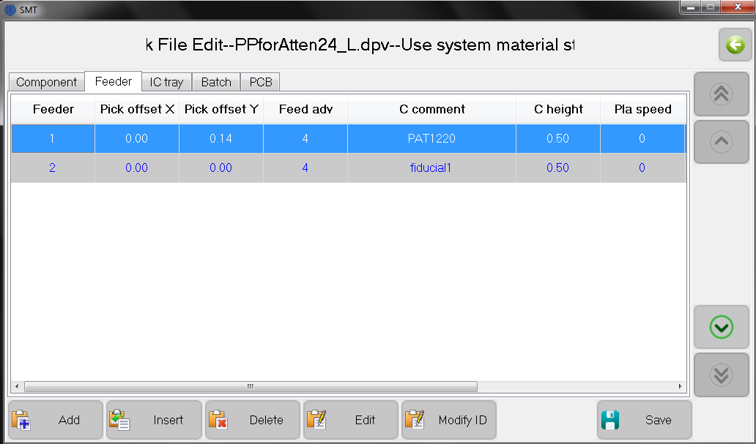

**Figure 10.6**. Window after “Run” / “Edit” / Feeder tab, listing feeders.

1. **Feeder:** Displays feeder information from work file. Note, all feeder information is not displayed in this list, but can be accessed from Edit;
2. **Add:** Add a new row to the end of the list;
3. **Insert:** Insert a new row before the present selected row;
4. **Delete:** Delete selected row. Note that all components using this feeder in the component list will also be deleted;
5. **Edit:** Edit selected material stack, as shown as below;
6. **Modify ID:** Changes feeder number.

When changing parameters in this feeder list, all components having the same feeder number will change.

1. **Feeder:** Set current feeder number. This value cannot repeat. The numbers

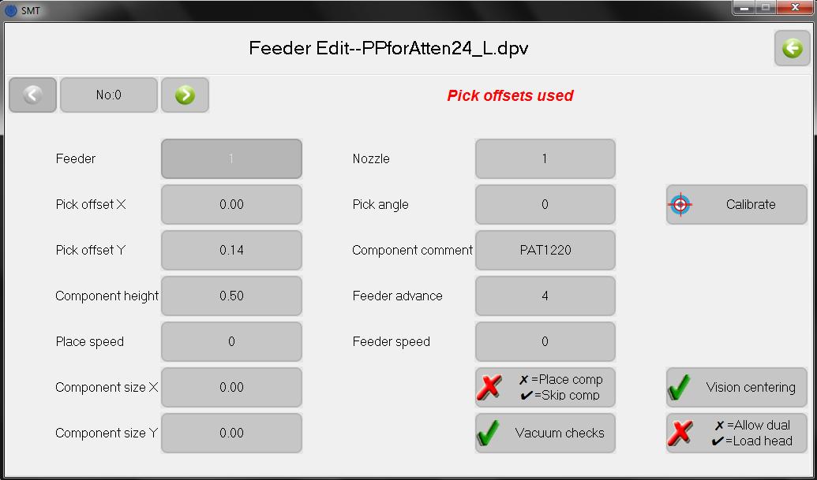

**Figure 10.7.** Window for editing feeders.

should be assigned by the user according to feeder type:

1-29: feeder tapes, at side of machine;

60-74: fixed IC tray, at front of machine;

80-99: user supplied IC tray, placed in PCB area;

1. **Pick offset X\Y:** Offset used to center nozzle to component at feeder;
2. **Component height:**
3. **Place speed:**
4. **Component size X\Y:** Size of feeder component (in mm), used for vision centering. Nominal value 0 is used for auto detection of size;
5. **Nozzle:**
6. **Pick angle:** Defines orientation angle of part being picked up, typically in 90-degree increments. Counterclockwise position is positive;
7. **Component comment:** Component annotation (such as C0.1uF-0805), used by this software to sort into feeder numbers;
8. **Feeder advance:** Distance between two successive components in the tape, units in mm. Typically set to 4, 8 or 12 mm;
9. **Feeder speed:** Speed of tape advance, 0 nominal;
10. **✗=Place component, ✔ = Skip component:**
11. **Vacuum checks:**
12. **Vision centering:**
13. **Calibrate:** Similar in function to calibrate component, which opens another window to align the feeder system. Details in next section;
14. **Pick offsets used:** Text in red, when option chosen in set parameters window.

#### Feeder Calibrate

The feeder alignment must be checked every job since the tape is installed by hand and the tape holes must be in the correct location for the needle pull operation. After clicking align feeder, the head moves to the chosen feeder and an image is displayed from the down camera.

**Vision mode:** First, use the camera image to align, by hand, the tape hole (red circle) against the feeder edge (blue line), as shown below. This gives an initial alignment of the pull needle to the pull hole, which is good enough for a tape pull.

取料位置

**Figure 10.8.** Image from down camera to align feeders.

**Nozzle mode:** By clicking the “Nozzle” button, the image will disappear and the nozzle will be centered over the component. Click the “pull needle” icon just below the Y coordinate to move the needle to the hole, lower the needle, and advance the, tape for a distance given by feeder advance parameter. This checks the advance operation and afterwards gives a more accurate machine alignment of the pull needle to the pull hole.

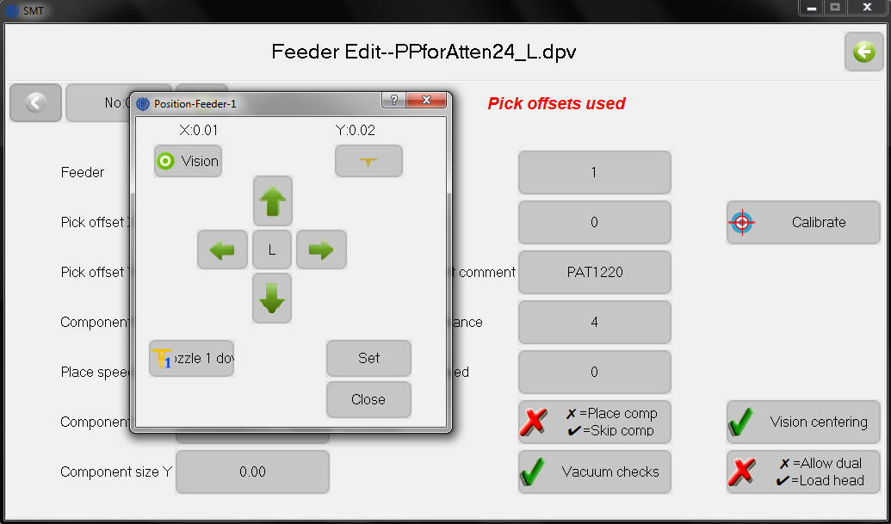

**Figure 10.9.** Window to advance the tape with the pull needle. “Needle advance” button is the icon just below the Y:0.02 text.

**Vision mode:** By clicking on the “vision” button, the image again appears. The arrow buttons can now be used to accurately center the image crosshairs over the component in the tape. Clicking “set” stores the pick offset parameters, which can be seen on the edit page after closing this window.

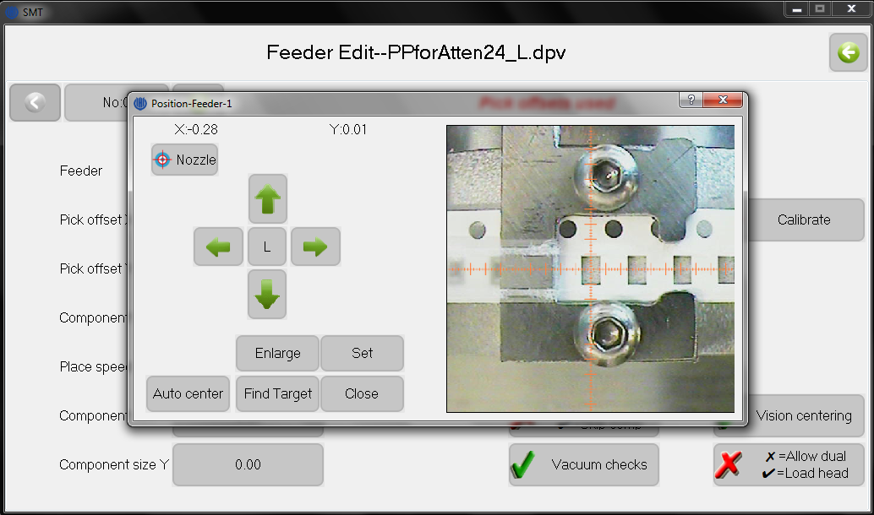

**Figure 10.10.** Window to align nozzle to feeder for the pick operation.

### IC Tray

The IC tray is used to pick-up components in the back PCB area of the machine, with locations defined by the user. The coordinates follow a sequence from left to right and front to back. The following window shows the pickup sequence. The IC tray list will be populated automatically if the feeder number is between 80 to 99.

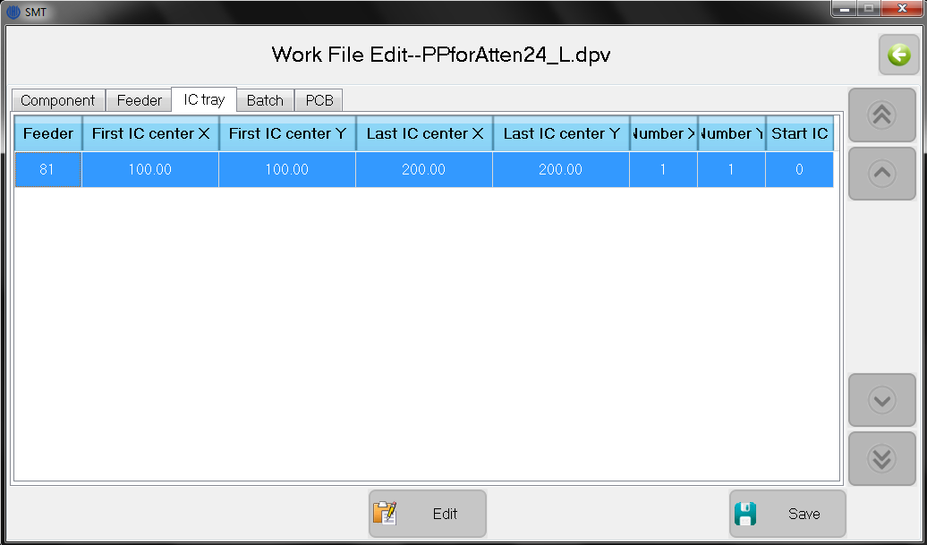

**Figure 10.11.** Window after “Run / Edit / IC tray tab”, for listing IC trays.

The edit commands, see below, are

1. **Feeder:** IC tray number
2. **First IC center X\Y:** IC center coordinate in the left bottom of IC array. The number can be input manually or determine by location;
3. **Last IC center X\Y:** IC center coordinate in the top right of IC array;
4. **Number X\Y**: number of components in X\Y direction;
5. **Start IC:** ICs are numbered (starting from 0) from left to right and down to top. If the start IC number is set, the ICs with number smaller than the start IC will be skipped.

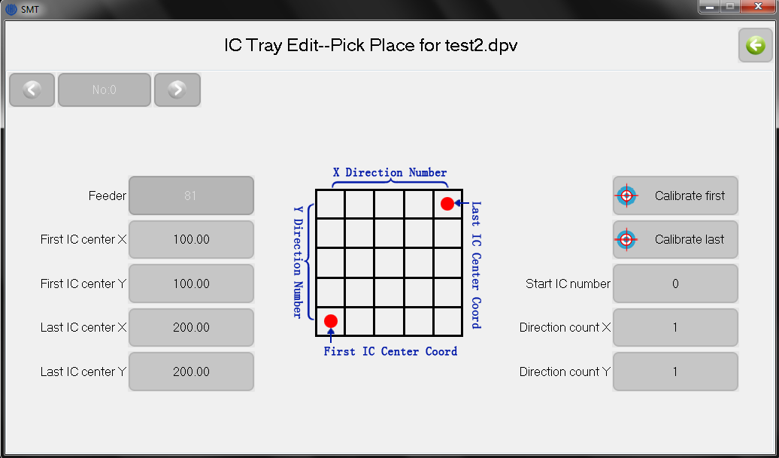

**Figure 10.12.** Window for editing batch parameters.

Note that the IC tray should not be put on the top of fixture pillar or the pull needle may run into IC tray and be damaged. The figure below shows how to clamp properly.

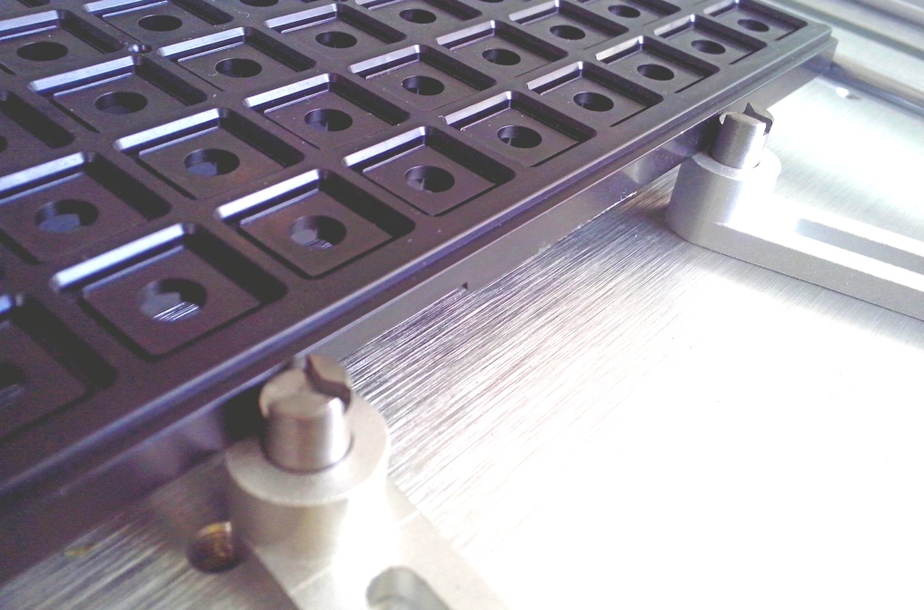

**Figure 10.13.** Photograph of user IC tray and method for proper clamping.

### Batch

Batch enables the population of a number of identical PCBs on the same PCB panel, which can then be cut apart after manufacture. Only one component list is needed for each sub-board. Note that each PCB must be parallel to each other.

Batch is defined in two ways. One is by coordinate, where the user defines the origin of each sub-board. The batch list must have at least one record, see below. The first origin is always set with zero offset, ignoring the “Place coordinate X\Y” value.

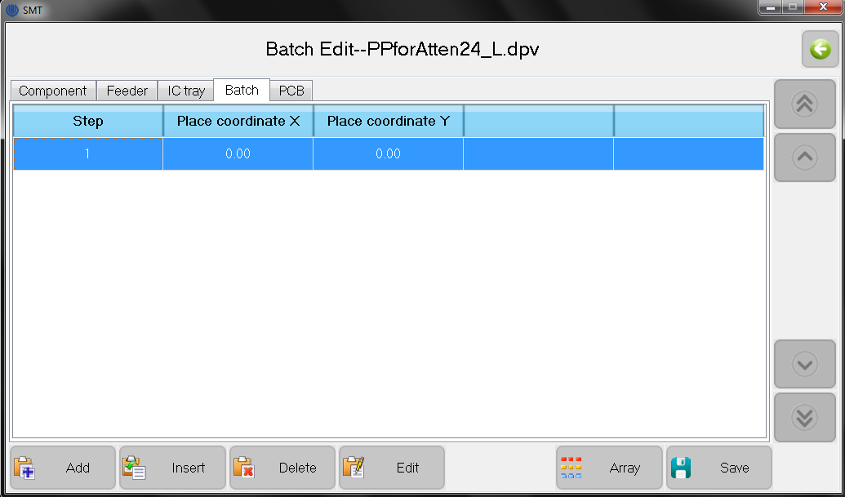

**Figure 10.14.** Window after “Run / Edit / batch tab”, listing batch steps.

The second batch method defines with an array, where each origin is calculated automatically from the row and column spacing and count. Parameters can change

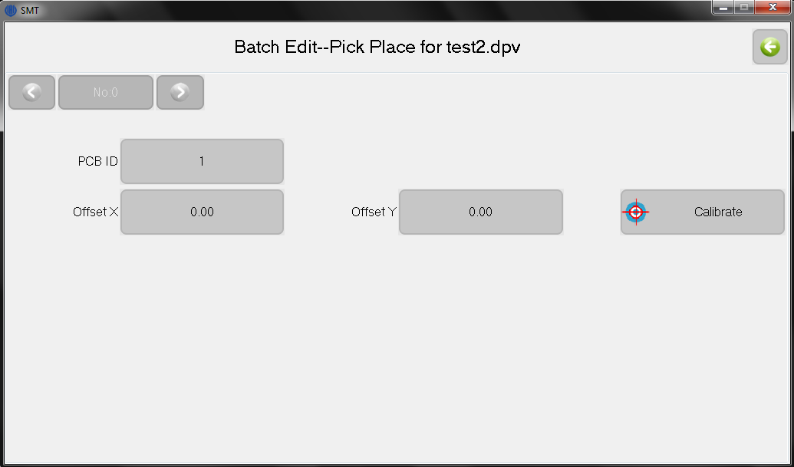

**Figure 10.15.** Widow for editing array parameters.

with the “Edit” popup window ,as show below.

1. **PCB ID:** Only used in coordinate (not array) mode.
2. **Spacing X\Y:** Spacing of two neighboring circuits
3. **Number X\Y:** Number of circuits in X\Y direction.

It is possible to skip circuits labeled by “PCB ID” by selecting the “Add skip” button.

### PCB

It is necessary to calibrate the position of the PCB in the machine. Two or three calibration points are defined in the screen shown below; this number can be changed in the “System set” menu. There are two methods to obtain the calibration points.

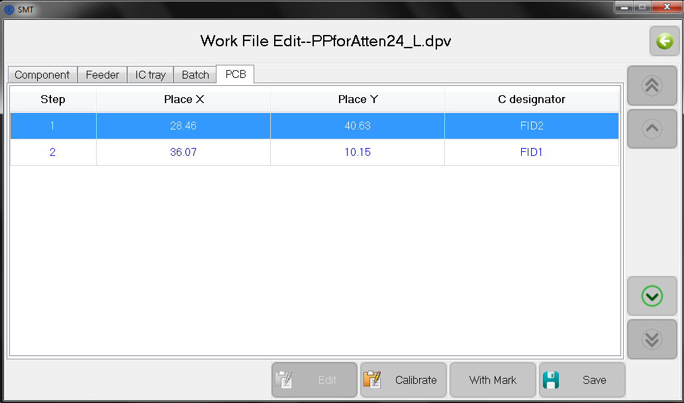

**Figure 10.16.** Window after “Run / Edit / PCB calibrate”, listing calibration points.

1. **Components:** The software automatically selects components and obtains their coordinates from the PCB file. In the designator column, the number after “P” indicates the batch PCB ID, “E” gives the component ID, and the string after “:” is the component designation. Alignment then uses these components;
2. **Marks:** The user selects two specific coordinates of the PCB. Fiducials on the PCB or board corners are typically used here;
3. **Calibrate:** As show below, the calibration points are selected for visual centering at those points. When selecting each button, a window opens as for component calibration. Arrows adjust the stage to center the mark, and set is clicked to record the offset. Although this calibration does not update the centering in subsequent PCB calibrations, its effect can be checked by editing a component and clicking calibrate to verify the component is now centered;
4. **Save:** Saves the set offsets for the PCB calibration;

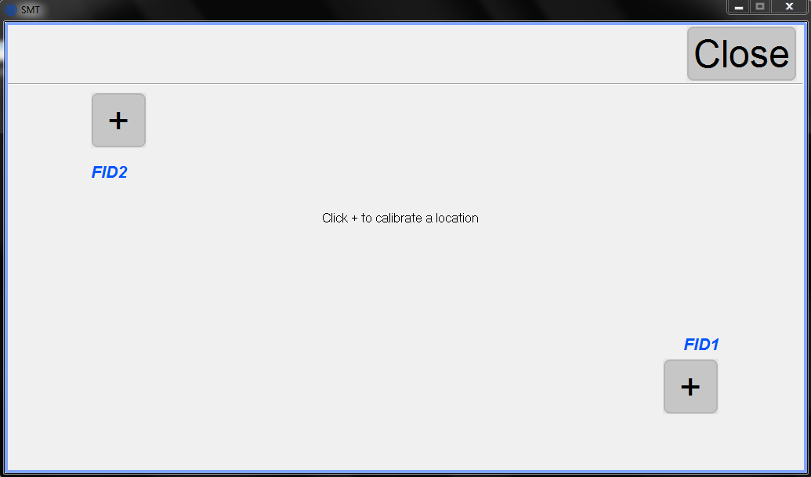

**Figure 10.17.** Window for calibrating PCB points.

## Load Work File

The load work window is used to run the machine and monitor its progress.

1. **Current step:** Showing current component step and total number, click to set the component step which will mount next;
2. **PCB ID:** For batch mode, show current PCB ID number and total. Click to set current PCB number, which will mount next;
3. **Place count.:** Show total count of placed components;
4. **PCB count:** For batch mode, show total count of PCB boards;
5. **Average speed:** Show average mounting speed, in chips per hour;
6. **Elapsed time.:** Run time;
7. **Adjust Tray Start:** When feeders are defined in the IC tray, this button appears. Click to set the start IC number;
8. **Up camera (bottom left):** Click to watch image of up camera;
9. **Down Light (2nd left):** Click to toggle light on and off;
10. **PCB calibrate (3rd left):** Click to calibrate the PCB position;
11. **Vacuum checks (4th left):** Click to toggle on and off the vacuum checks;
12. **Head to Home (5th left):** Click to send head to home position, at back-right**;**
13. **Step++:** Place components one step and operation at a time. Used for testing;
14. **Run:** Run normally;
15. **Stop:** Stop placement;

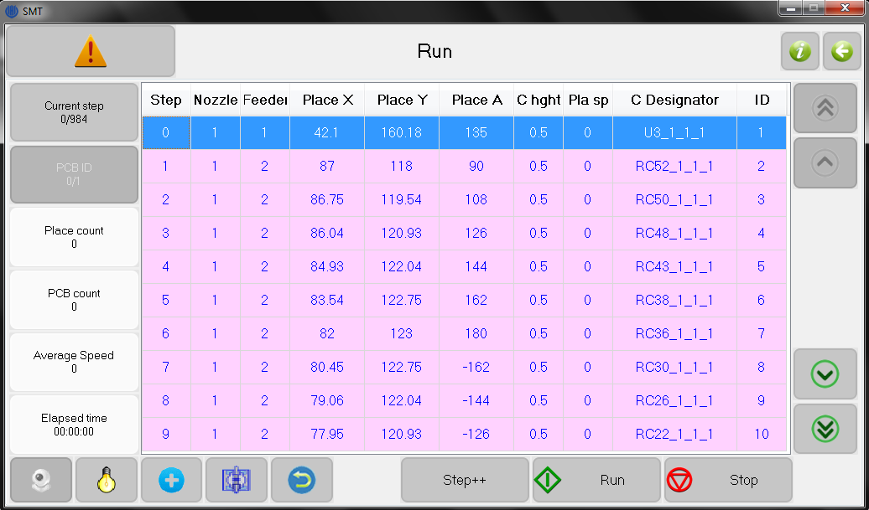

**Figure 10.18.** Window after “Run / Load”, to run work file.

# Diagnostics

The test window is used for testing modules to check for proper operation.

1. **Nozzle 1\2 down:** Nozzle lowers when button pressed;
2. **Nozzle 1\2 vacuum:** Nozzle vacuum turned on;
3. **Nozzle 1\2 rotate:** Nozzle rotates 180º anticlockwise when button pressed;
4. **Nozzle 1\2 air:** Nozzle air turned on;
5. **UpLight\DownLight \toggle:** Light toggled on and off with each click;
6. **Tape-cover collect:** Click to advance collector of tape cover;
7. **Needle down:** Needle pushed down to tape when button pressed;
8. **Needle to tape pull…:** Enter feeder number entered and move needle to pull position of tape;
9. **DownCamera\Nozzle to feeder …:** Move down camera or nozzle to feeder number.
10. **DownCamera\Nozzle to PCB origin:** Move down camera or nozzle to PCB origin at front-left;
11. **DownCamera:** Images down camera, with movement buttons;
12. **Origin reset, home:** Reset the origin at front-left, then move to home;
13. **Nozzle 1\2 to UpCamera:** Move nozzle 1\2 to position of up camera;
14. **Home (back-right):** Move head to home at back-right.

Note: Parameters changed in this window will not be saved.

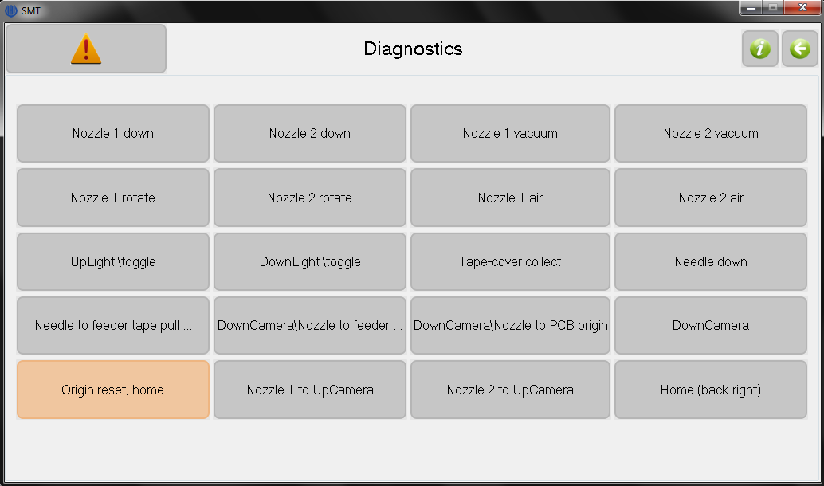

**Figure 11.1.** Window after “Diagnostics”, showing diagnostic functions.

# Set

The set window is used to set parameters.

1. **Vacuum checks:** Click to globally toggle on and off; described previously;
2. **Vision centering:** Click to globally toggle on and off; described previously;
3. **Visual component detection**: Click to toggle on and off. If checked, when a component is not detected on nozzle, then new material will be re-picked. After 6 times not detecting a component, the machine alarms and stops;
4. **Detect Z-Axis**: Check to start Z axis detect. If checked, the Z axis is found to be lost when the stick is attached, then the Z axis is automatically returned to the origin. This feature can be avoided due to the high level of the device is not set up to cause the Z axis, damage to the device parts;
5. **Place Speed:** Global set of running speed of machine;
6. **System set:** Set advanced parameters with special codes;
7. **Date and time set:** Setting system time;
8. **Clear statistic logs:** Click to clear all statistic logs;
9. **Clear system logs:** Click to clear all system logs;
10. **Component place offset:** Global offset for all components in X, Y and angle, applied only during place operation and not during vision and calibration. Used to fine-tune component locations on the PCB. Offsets are not saved when closing the software.
11. **Serial number:** The lower left corner displays the hardware serial number.

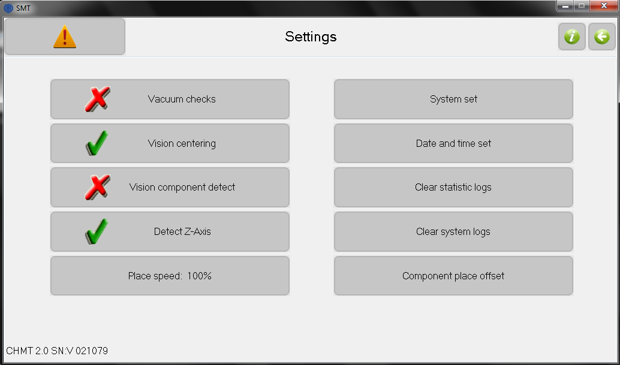

**Figure 12.1.** Window after “Set”, showing setting choices.

## System Set

After clicking the “system set” button and entering the code “123456”, the “system set” window is displayed. It is used to set system parameters and perform calibrations. Some calibrations and functions are similar to described previously in the “Run” section.

1. **Calibrate cameras:** Calibrates camera locations using the vision system.

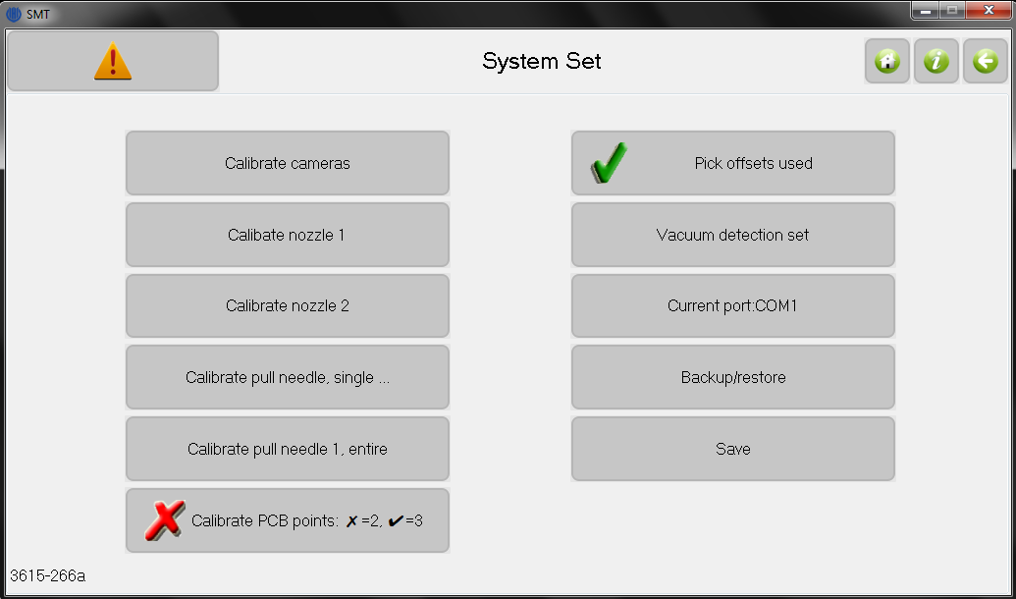

**Figure 12.2.** Window after “Set / System set”, showing system set choices.

* + 1. After clicking, a window opens with the up-camera image, as shown below;
    2. Place the calibration board on the up camera. Manually adjust its position to center on the crosshairs;
    3. Click “Set” to next view the down camera;
    4. With arrows, position of the down camera to center on the calibration board;
    5. Click “Set” to finish the calibration;

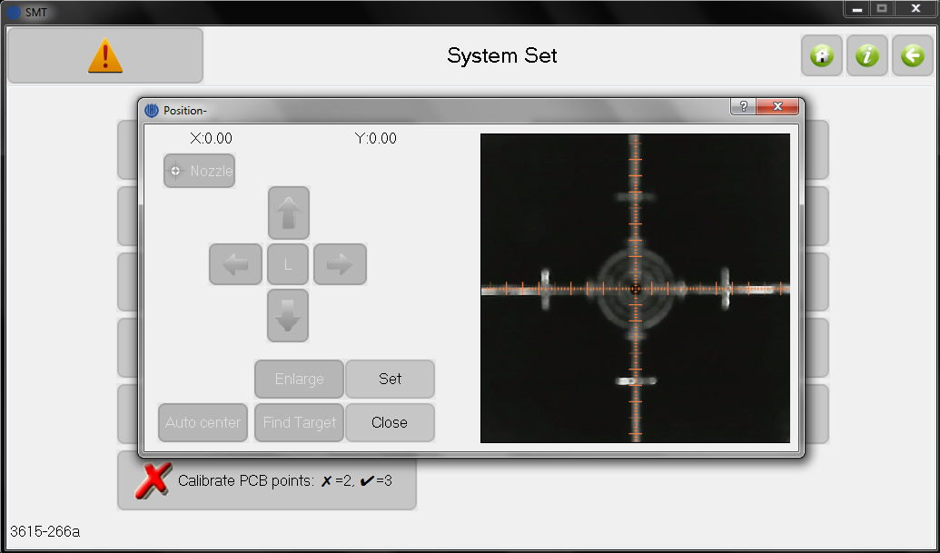

**Figure 12.3.** Up-camera image of the calibration board.

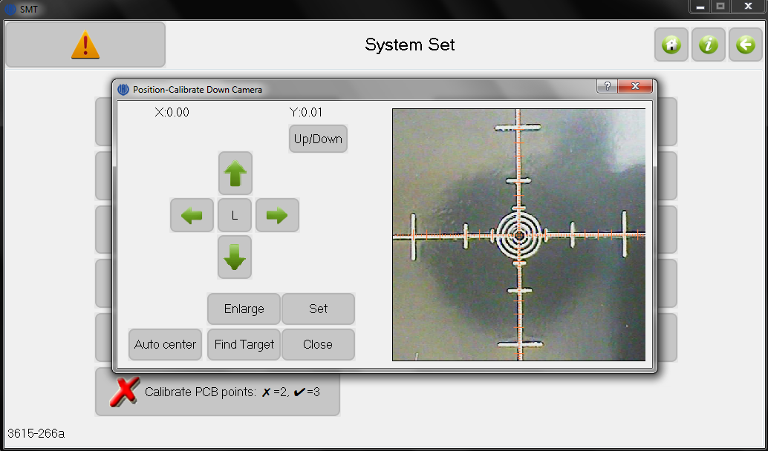

**Figure 12.4.** Down-camera image of the calibration board.

1. **Calibrate nozzle 1\2:** This alignment must be done after the step “calibrate cameras”. In the popup window, move the nozzle to the center of the crosshairs and click “Set”;
2. **Calibrate pull needle, single …:** This alignment was described previously in the “Align Feeders” section.
3. **Calibrate pull needle 1, entire:** Align feeder 1, then applied to all feeders using known locations separations. Use for initial (coarse) feeder settings;
4. **Calibrate PCB points:** Chooses 2- or 3-point calibration for PCB.
5. **Pick offsets used:** Button toggles on and off to enable offsets to the feeders for the pick operation, as defined as the feeder offset in the “Run / Edit” section. When selected, red text is shown in “Feeder Edit” window;
6. **Vacuum detection set:** View and set parameters of the vacuum setpoints; see section below for details;
7. **Backup/** **Restore:** Backup and restore all of parameters in system set;
8. **Save:** Click to save changes of system set. If system parameters were modified without saving, then old parameters will be used after next restart;
9. **Software identification:** The lower left corner displays the software version;

## Vacuum Detection Set

The window is show below.

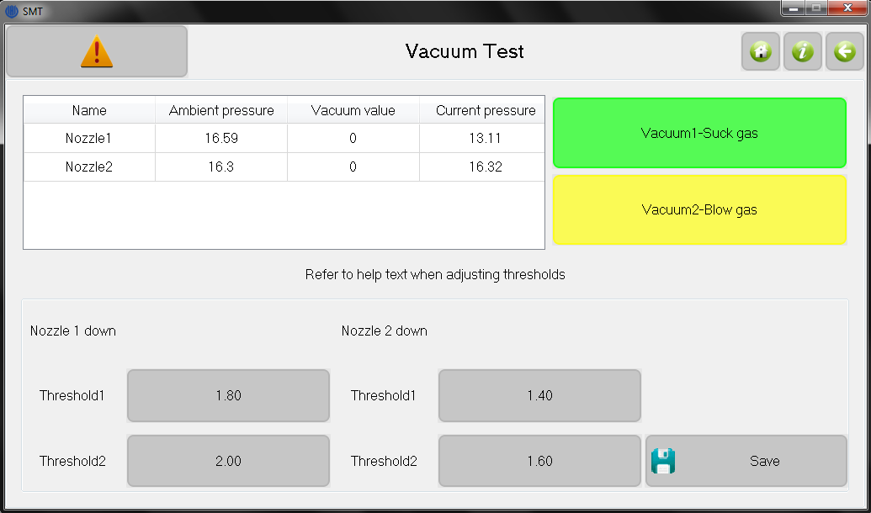

**Figure 12.4.** Window after “Set / System Set / Vacuum detection set”, for editing vacuum threshold parameters.

1. **Vacuum 1\2-suction\blow \toggle:** Toggle nozzle for suction or blowing gas;
2. **Air pressure status list:** The pressure values here are only valid after at least one suction operation, or it will display 0. Ambient pressure is detected before pressure operation, while vacuum value is change in pressure. A bigger number indicates a larger pressure difference;
3. **Nozzle 1\2 threshold1:** Lower limit of vacuum. If below this value, no component is detected to be held by the nozzle and pick-up will be retried. Otherwise the vacuum will be tested for threshold high;
4. **Nozzle 1\2 threshold2:** Higher limit of vacuum. A bad component is detected if below this value, and will be thrown away. Otherwise the component is placed;

The order of the pressures (low to high) and recommend thresholds are

* + - 1. vacuum with no component
      2. threshold 1 = threshold 2 - 0.2
      3. threshold 2 = vacuum with component - 0.3
      4. vacuum with component

1. **Save:** Save changes;

## Backup/Restore

Screen as show below.

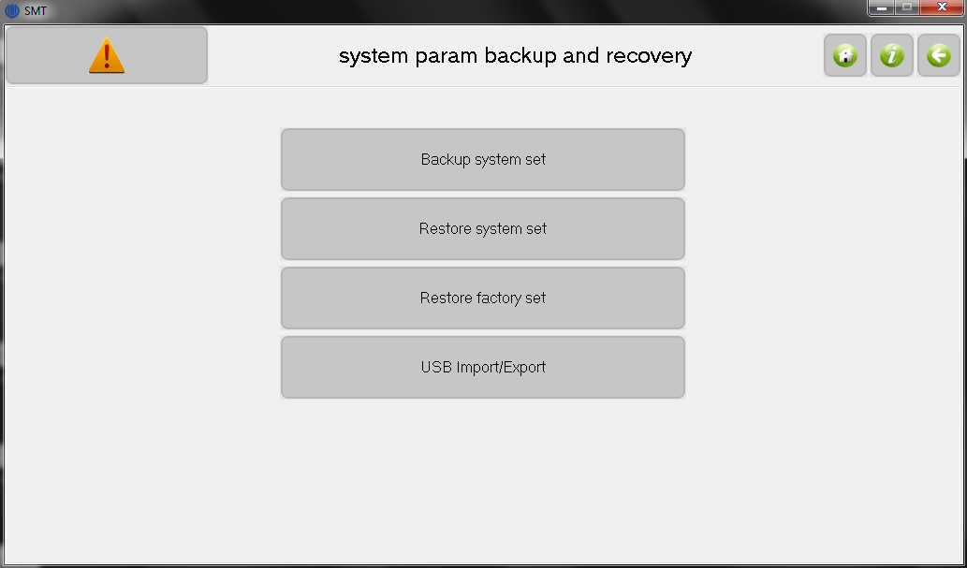

**Figure 12.5.** Window after “Set / System Set / Backup/Restore”, used to change storage of system parameters.

1. **Backup system set:** Backup all of system parameters;
2. **Restore system set:** Restore all of system parameters;
3. **Restore factory set:** Restore all of system parameters to factory;
4. **USB** **Import/Export:** The button is enabled when the USB storage device is connected. Note the imported parameters will not change the system settings directly, only when executing restore system set.

# Files

Used for managing work files and production files, which are generated by PCB software. The window is show below.

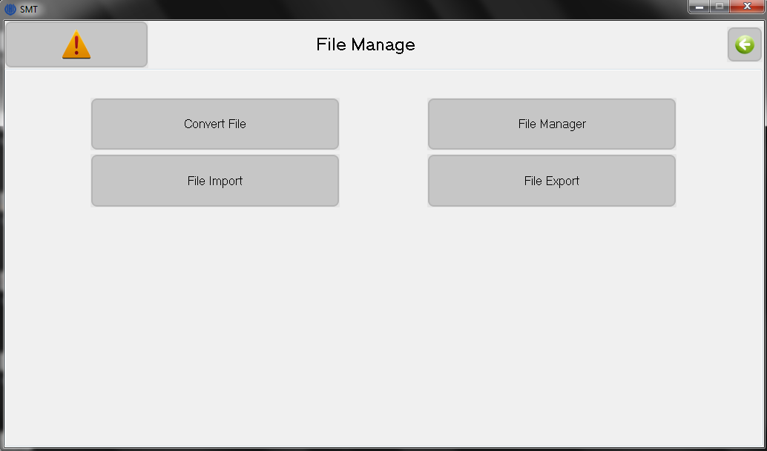**Figure 13.1.** Window after “File”, for converting CSV files and file functions.

1. **File Convert:** To use CSV files generated by the PCB software, the CSV file must first be converted. The usage of convert tool is shown below;
2. **File view:** Browse all CSV and work files in system;
3. **File Import\Export:** Import or export CSV file or work file. Buttons valid when USB storage device is connected;

## Generating the CSV File

### Altium Designer

1. In the PCB design, identical components must have the same comment, as the feeder is sorted by the comment field;
2. Set the PCB origin, as shown below, by setting the top layer origin at the bottom left corner of the PCB. For the bottom layer, set the origin to the bottom right corner and use mirror imaging when loading the CSV;

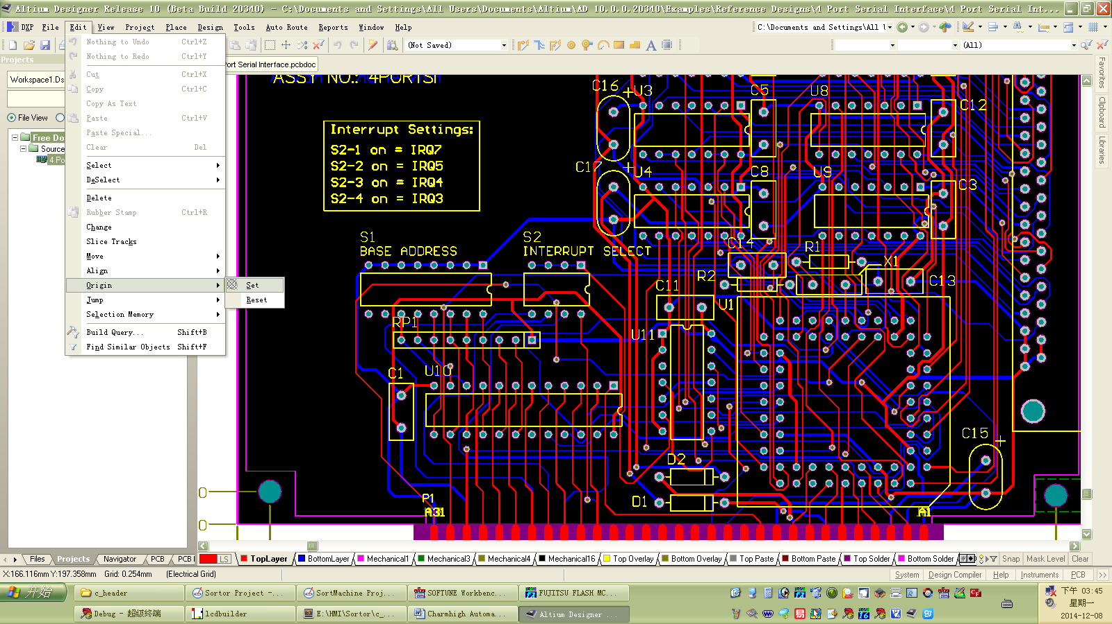

**Figure 13.2.** Image of Altium program, showing setting the origin.

1. Altium showing “File / Assembly Output / Generates pick and place files”;

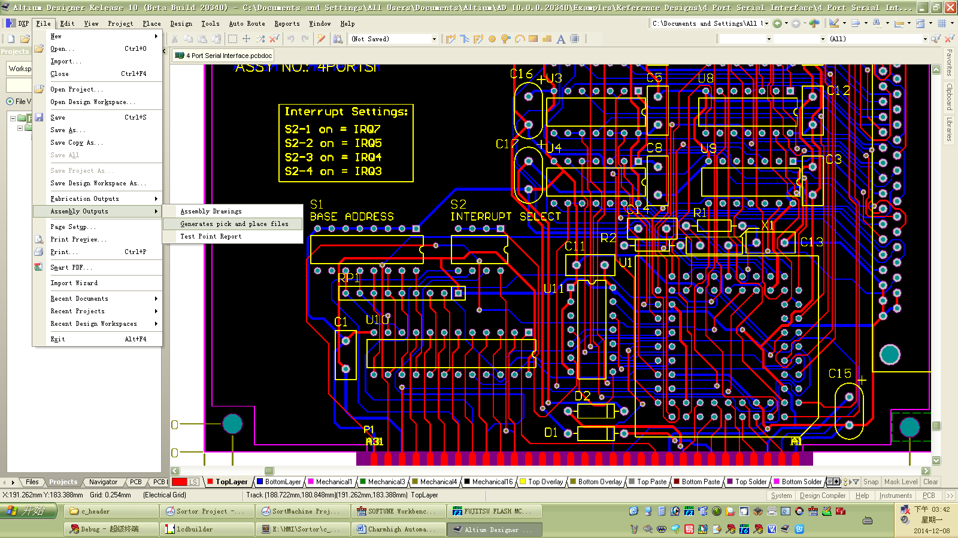

**Figure 13.3.** Image of Altium program making a pick and place file.

1. As shown below, select “CSV” and “Metric” in the popup dialog box, click “OK” to finish. The generated CSV file can be found in same directory as project outputs.
2. The CSV format is given by

Designator/Footprint/MidX/MidY/RefX/RefY/PadX/PadY/Layer/Rotation/Comment

where black=input data, blue=displayed and green=not used. The data is not read properly if unused columns are deleted.

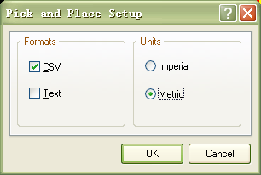

**Figure 13.4.** Altium showing dialog box, for setting CSV output format with mm units.

1. RefX\Y is the user-defined reference point; Pad X\Y is the pad 1 coordinate.

### Protel

1. Open existing PCB file, note, same component must have same designator, otherwise one component may occupy more than one material stack, since convert tool identifies different material stack by designator of component;
2. Selecting “Edit / Origin / Set” in menu bar to setting PCB origin, note, for top layer setting origin in left bottom corner of PCB, for bottom layer setting origin in bottom right corner of PCB and check mirror image option when converting;
3. See figure below, select “File / CAM Manager” in menu bar;

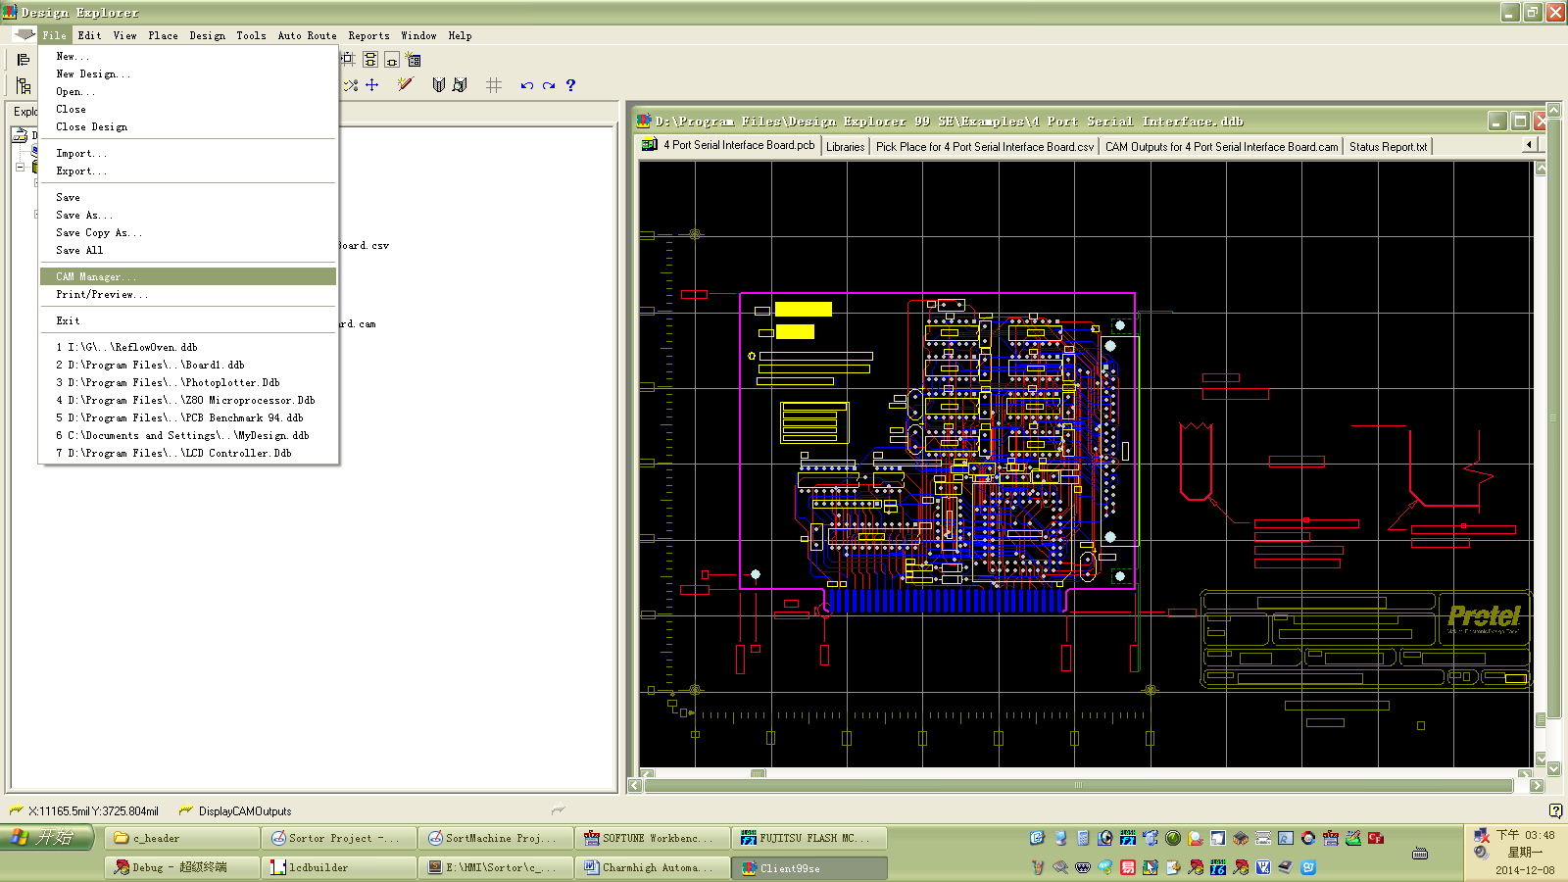

**Figure 13.5**

1. See figure below, select “Pick Place” and then click “Next” in popup dialog box;

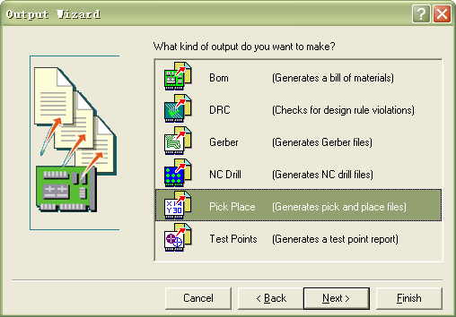

**Figure 13.6.**

1. See figure below, input file name, then click “Next”;

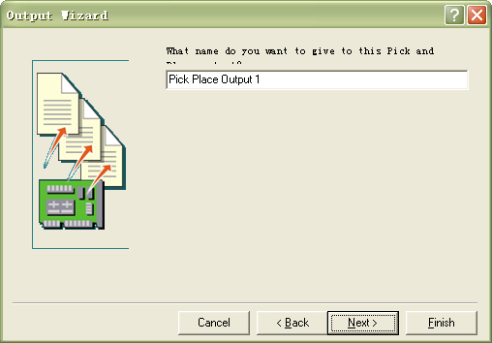

**Figure 13.7.**

1. See figure below, select “CSV” then click “Next”;

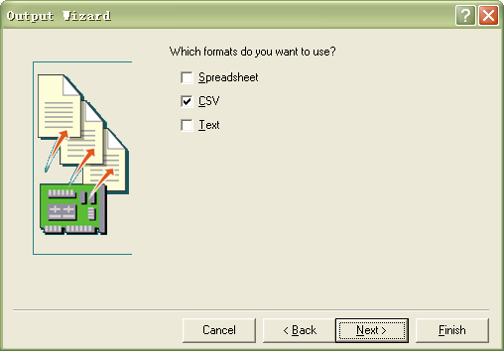

**Figure 13.8.**

1. See figure below, select “Metric” then click “Next”;

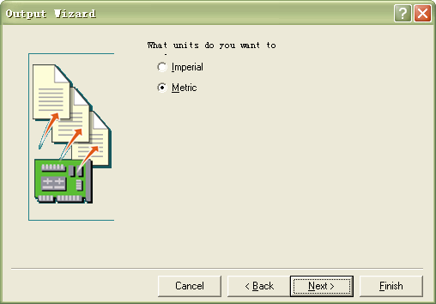

**Figure 13.9**

1. See figure below, right click the file just generated in the list, select “Generate CAM Files” from popup menu;

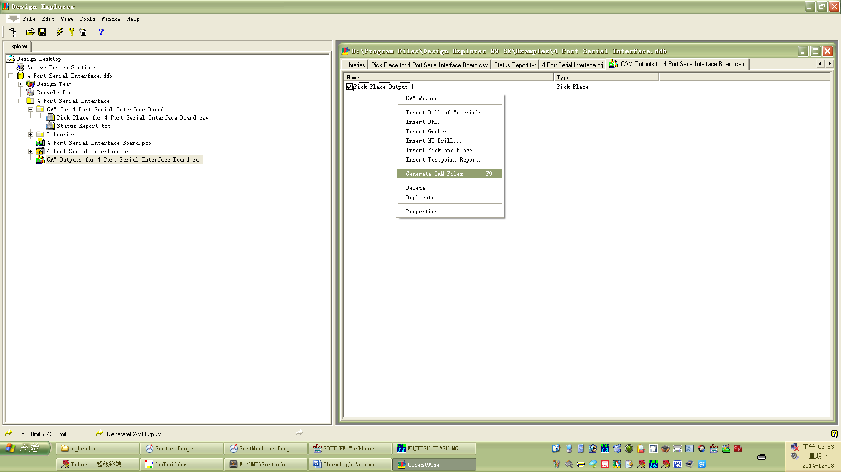

**Figure 13.10**

1. See figure below, right click the “CAM” folder just generated, select “Export” from popup menu to finish.

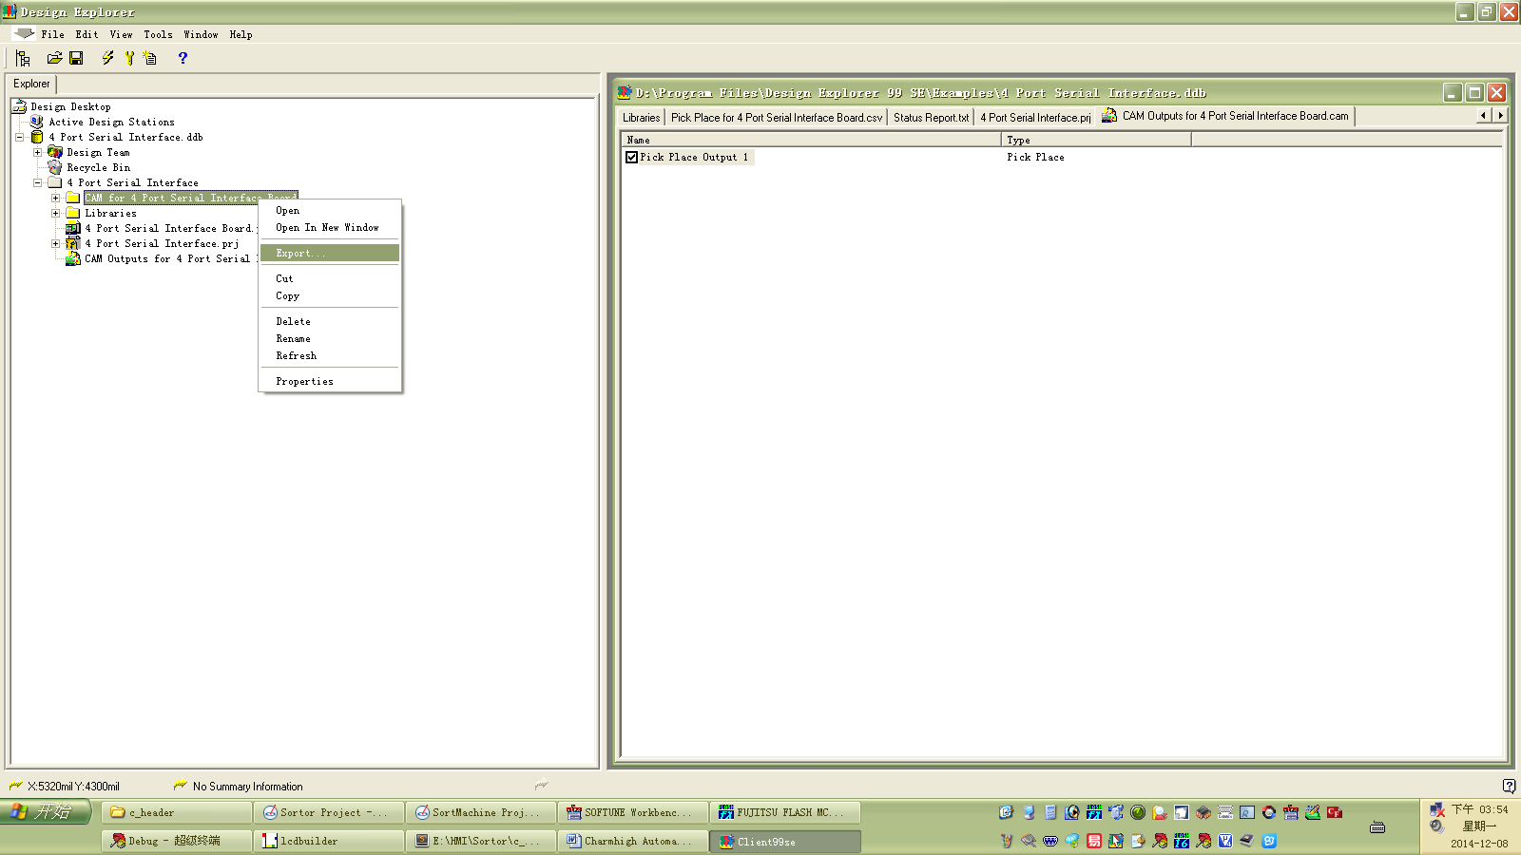

**Figure 13.11**

## File Convert

After selecting Convert File, the CSV files are listed as show below.

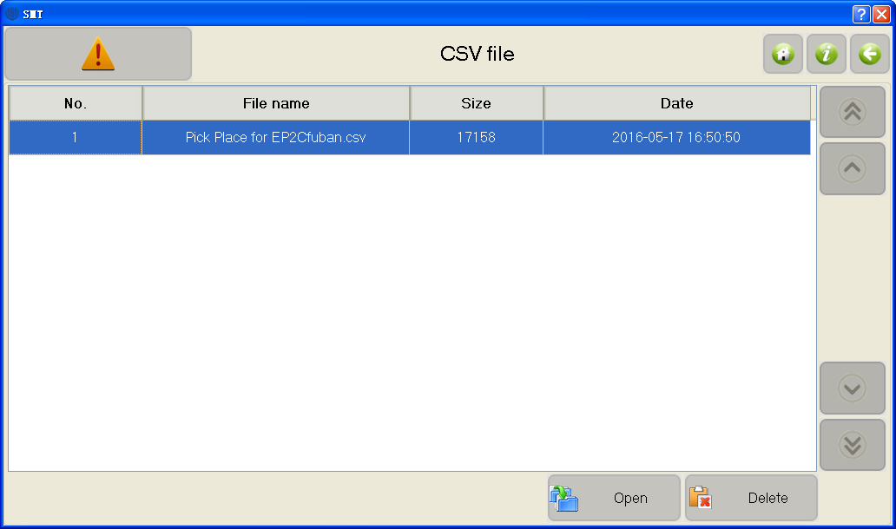

**Figure 13.12.** Window after “File / Convert File”, listing CSV files.

1. **Open：**Open selected CSV file;
2. **Delete：**Deletes selected CSV file;

The read-in file is shown below. Click “Settings” and then “convert”.

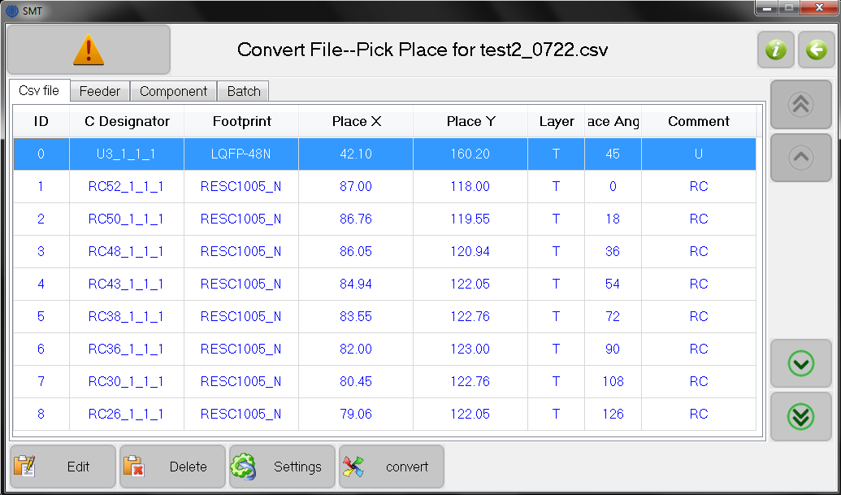**Figure 13.13.** Window after “File / Open”, showing CSV entries.

1. **Edit:** Edit information of selected CSV item;
2. **Delete:** Delete selected CSV item;
3. **Settings:** Set conversion for top or bottom layer. When bottom, mirroring is normally checked;
4. **Convert:** Convert CSV file to work file;

### Feeders

After conversion, the feeders tab is displayed, as shown below. The converted file is typically saved next since it can be edited later in the “Run / Edit” menu. The height listing of 50 seems to be an error as it is set to 0.5 when loaded to run. Useful functions here are setting the angle orientation of the picked components.

1. **Rotate 180:** For the selected feeder, the component is rotated 180 degrees;
2. **Rotate 90:** For the selected feeder, rotated 90 degrees.
3. **Save:** Save converted work file.

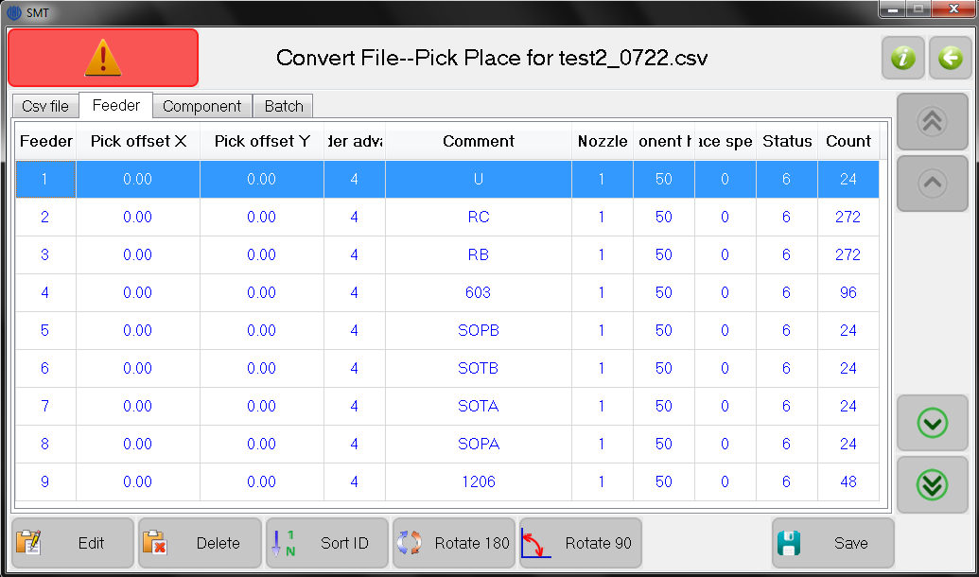**Figure 13.14.** Window after “File / Convert File / Open / Convert / Feeder tab”.

### Components

The components window is show below. The new functions are

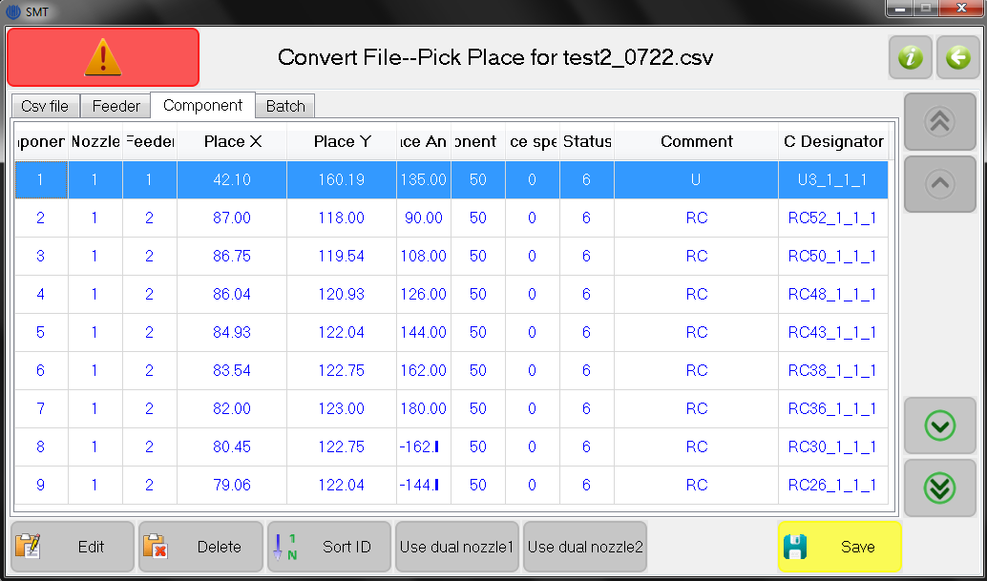**Figure 13.15.** Window after “File / Convert File / Open / Convert / Component tab”.

1. **Use dual nozzle1:** Check indicates that two components will be picked at one time by two nozzles, from the same feeder.
2. **Use dual nozzle2:** Check indicates that two components will be picked at one time by two nozzles, from different feeders;

### Batch

Setting up a batch is illustrated in the window show below. The functions are similar to that described previously in the “Run” section.

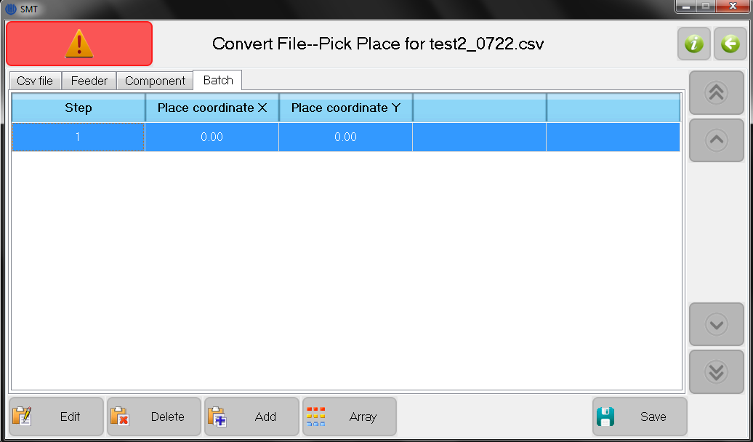**Figure 13.16.** Window after “File / Convert File / Open / Convert / Batch tab”.

# Log

The log window is show below.

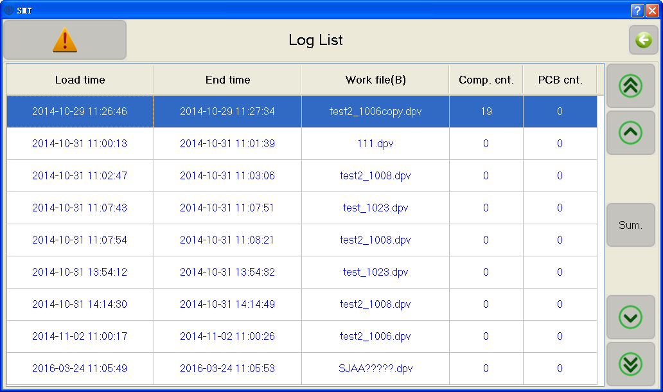

**Figure 14.1.** Window after “Log”, showing past work jobs.

1. **Log list:** Each line records information of running one time;
2. **Sum:** Shows component count mounted for each feeder in table.

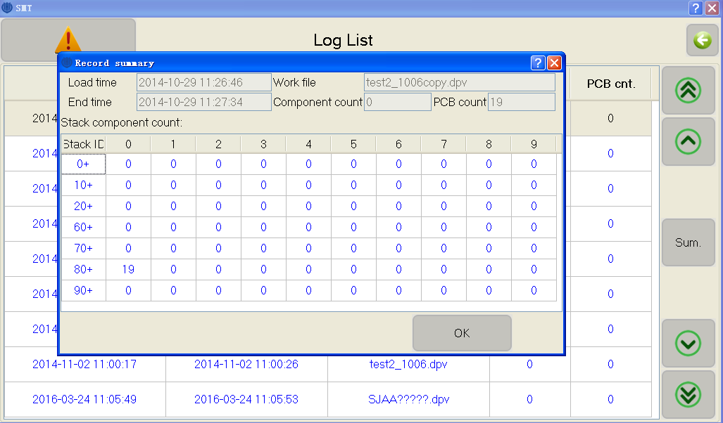

**Figure 14.2.** Window after “Log / Sum”, showing more detailed statistics.

# System Log

System log is used to view records generated by the system.

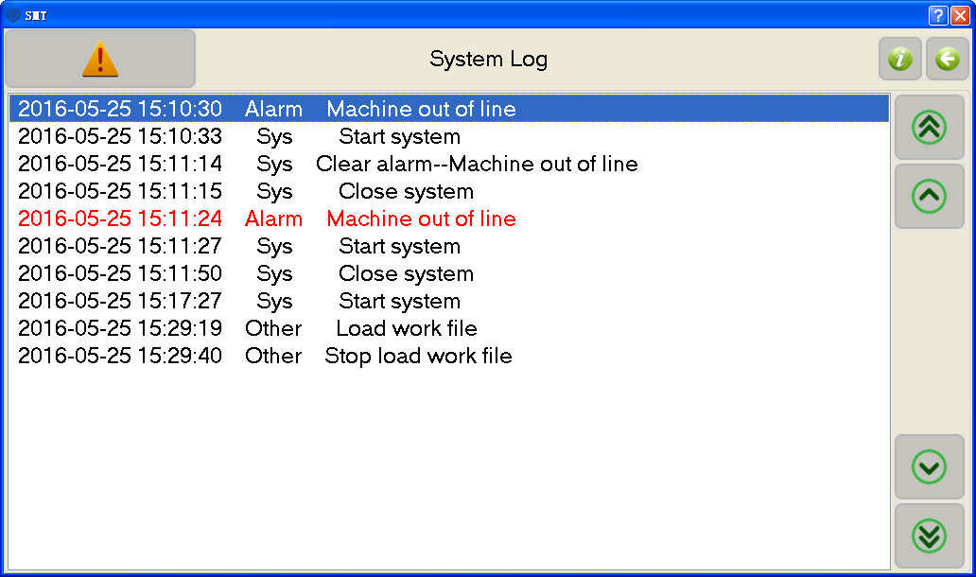

**Figure 15.1.** Window after “System Log”, showing system records.

# Feeder Hardware

Parts are installed in feeders corresponding to its feeder number set in the software. Feeder parameters are displayed in the feeders tab. There are 3 feeder types:

1. **Tape feeders:** Feeders 1-29 are used to load parts embedded in tape, which accommodates 3 different widths:
   * 1. 8 mm feeders 1-22;
     2. 12 mm feeders 23-26;
     3. 16 mm feeders 27-28;
     4. 24 mm feeder 29;

Tapes of a given width can have different part spacing (typically 4, 8 and 12 mm), so the “feeder advance” must be entered to specify this parameter.

Tapes are loaded on the left side of the machine with the following procedure.

* + 1. If the tape is on a reel, place it on the three disks, with the tape feed and cover film on the top. See Fig. 16.1 below.
    2. Thread the tape under the rod.

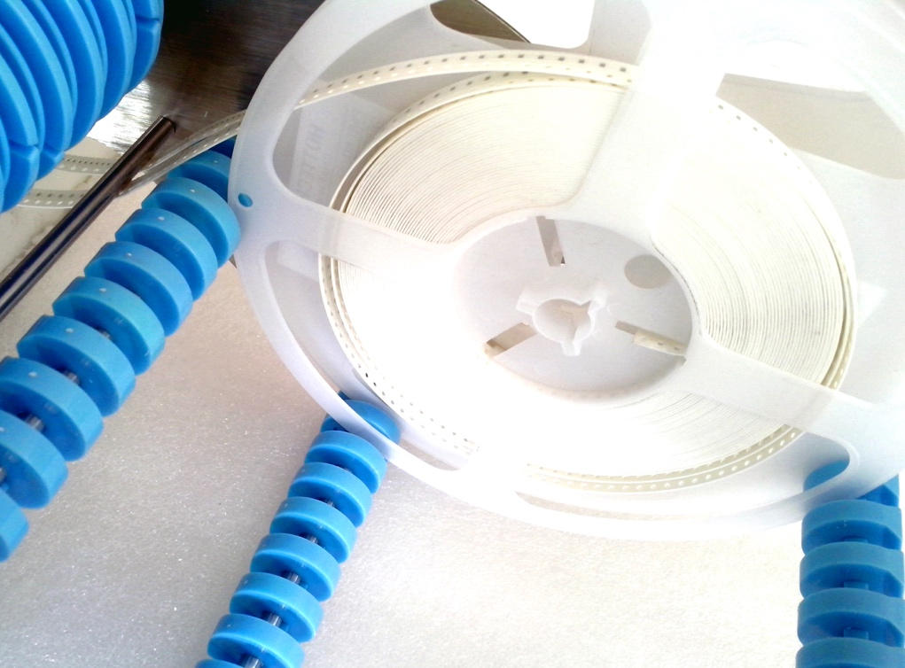

**Figure 16.1.** Image of tape reel on 3 disks, with tape threaded under rod.

* + 1. Thread the tape into the feeder. Separate the cover film from the tape and feed it back over the metal batten (blue line in Fig. 16.2). Thread the tape so that it extends past the final screws.

拉针位置

**Figure 16.2.** Tape feeders, with cover film (semi-transparent) pulled back over batten (blue line). Green circle is the position for the needle pull.

* + 1. If cover film is short, attach a tape extender. Thread it under a second rod and to the top of the belt receiving wheel, as pictured in below.

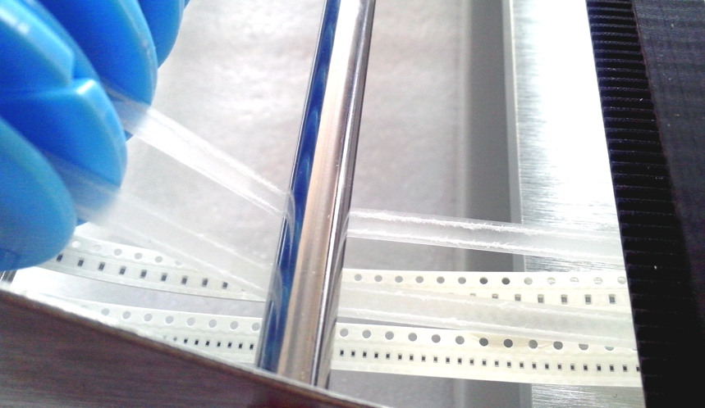

**Figure 16.2.** Image of film cover threaded to belt receiving wheel.

* + 1. Manually align the round hole of the tape to the edge of the batten, as shown as red hole and blue line in Fig. 16.2.

1. **Fixed IC tray:** Feeders 60-74 are used to load individual parts, typically ICs, from fixed trays located at the front of the machine. Numbering starts at the front-left and continues to the right and then back, and then to the rightmost two trays. For position and angular alignment, parts are typically set at the back-left edge of a tray. Pick-offset parameters in the “Run /Edit / Feeder tab / Calibrate” then program the machine to pick up the part at its center instead of the tray center.
2. **User IC tray:** Feeders 80-99 are used to load external trays of parts from the back of the PCB area, as discussed previously.

# Nozzle Hardware

Nozzles are chosen according to component size. Typical choices and pictures are shown below.

Nozzle Component size

502 0401

503 0603

504 0805, 1206, SOT23, etc.

505 SOP8, SOP14, etc.

506 QFN, TQFP, etc.

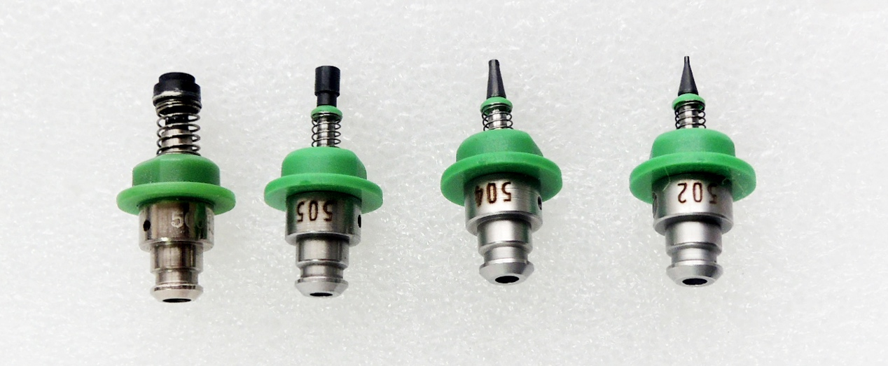

**Figure 16.4.** Nozzle types 502, 504, 505 and 506 (left to right).

# PCB Clamps

The printed circuit board is held by clamps in the center of the machine, aligned to the front-left corner. Standard PCB thickness is 1.6 mm (0.062 inches). Default height parameters need to be changed for boards with different thickness.

# Work Flow

1. **Create CSV file:** Export CSV (pick-and-place) file by your PCB design software. Units must be mm. (13.1);
2. **Start Machine:** Turn on the power switch on right side. (9);
3. **Run SmtMain:** Double click on icon to start control program. (9);
4. **Check origin (optional):** When starting, the stage sets its origin using limit switches. To check for drifts, image the PCB origin with the down camera by selecting “Diagnostics / DownCamera\Nozzle to PCB origin”. (11);
5. **PCB:** Place PCB against left stop in PCB clamp area. (18)**;**
6. **Import CSV file:** Import CSV data and convert to a work file. (13.2);
7. **Edit work file:** Choose “Run / Edit”. (10.1). When done, save. Typical inputs:
   1. **Feeder tab:** Define the feeder parameters. (10.1.2);
      1. Note or edit the “feeder” number to match the parts;
      2. Edit feeder parameters for proper “feeder advance” and “pick angle”;
      3. Place tapes and parts in corresponding feeders. (16);
      4. Perform a needle pull to calibrate position of tape in feeders and check pick location, using “Run / Edit / Feeder tab / Edit / Calibrate” (10.1.2.1);
   2. **PCB tab:** Define calibration locations on the PCB;
      1. Calibrate with 2- or 3-points in “set systems parameters”. (12.1);
      2. Define the calibration points in “PCB calibration”. (10.1.5);
      3. Calibrate position of PCB. Do in “Run / Edit” to save calibration. (10.1.5);
8. **Nozzles:** Choose and install nozzles in head. (17);
9. **Run work file:** Choose “Run / Load”. (10.2);
   1. **Step by step:** Choose “step++” to check if working normally. (10.2);
   2. **Component check (optional):** Look at first component with “Run / Edit / component tab / edit / calibrate” (10.1.1.2) and check if aligned well. To offset rest of components, measure offset and use “set / component place offset”. (12);
   3. **Run:** Components placed continuously. Click “Stop” if machine alarms or parts fed or placed improperly. (10.2);

# Maintenance

* Close software before switching off the power;
* Clean after using;
* According to use, smear some grease to bearings regularly;
* Cover machine if unused for a long time.

# Warranty

* Warranty range: SMT machine itself;
* Warranty period: 12 months;
* If there are problems in using, please contact us promptly, and do not repair by yourself to avoid damage to machine, or will lose your warranty;
* If accessories are breakdown, we will send a new one to you after receiving the break one;
* During warranty period, freight of send back to us is paid by user, freight of send to user is paid by us;
* Problems caused by below, we provide paid repair during warranty period:
* Faulty operation, disassembly without permission;
* Using beyond specification;
* Crash or improper placing when using;
* Using environment that do not fit for specification;
* Wrong power supply;
* Earthquake, fire, lightning or accident beyond control;